**Server Configuration Update Instructions**

**Step 1**: View Existing Cron Jobs

To see the current cron jobs configured on the server, run the following command:

Enter command : **crontab –l**

**Step 2**: Navigate to Backup Script Directory

Change your current working directory to the location of the logs backup script. In this case, it's the **pro-logs-bak** directory.

Go to this location : **cd /home/ec2-user/pro-logs-bak**

**Step 3**: View the Backup Script

Inspect the contents of the logs backup script using the **cat** command:

Enter command : **cat logs-backup.sh**

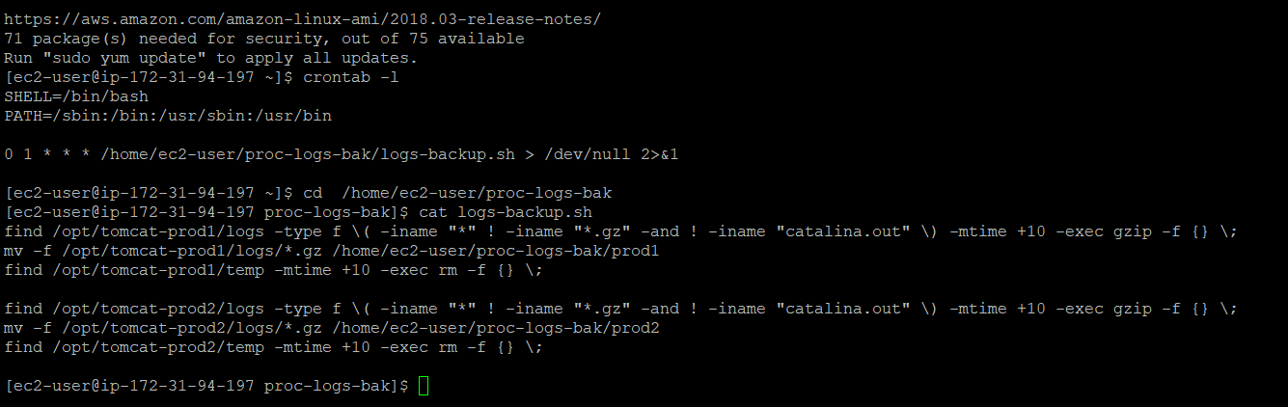

Step 4: Edit the Backup Script

Open the logs backup script in the text editor **vi**:

Enter command: **vi logs-backup.sh**

Step 5: Modify the Backup Interval

Inside the vi editor, press **i** to enter insert mode.

Locate the line with **+10** (indicating a backup interval of 10 days).

Change **+10** to **+5** to update the backup interval to 5 days.

Press **Esc** to exit insert mode.

Type **:wq!** and press **Enter** to save and exit the vi editor.

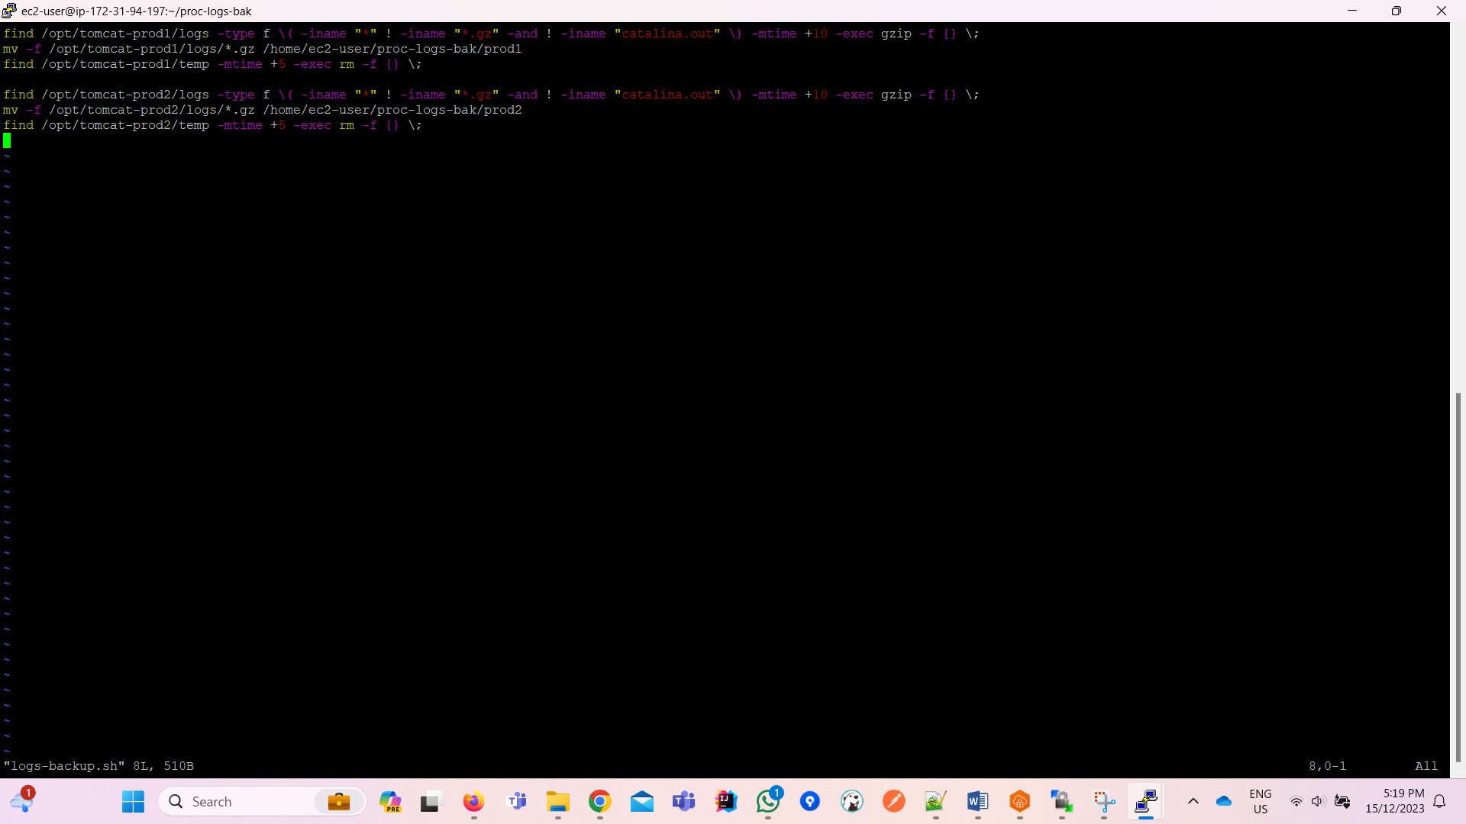

Step 6: Confirm Changes

Revisit the logs backup script to ensure the modification was successful:

**cat logs-backup.sh**

